Assignment 2 - Group report

COMP20008 - Elements of Data Processing

COMP20008

**“How does the economics of Victoria be affected?”**

**Group 41:**

Yiqun Yang 1254804,

Sen Wu 1254867,

Jingyi Gao 1255094,

Deyu Miao 1118866

1. **Research Question and Link.**

Economy is the foundation of every country's development or a state, and sustainability must have the material guarantee provided by economic growth. In real life, we usually use GDP to judge a country's economic development RGSP-Real Gross State Product to evaluate a state economic development. RGSP is the result of the productive activities of all resident units in a state during a certain period. RGSP is the core indicator of state economic accounting, and an important indicator to measure the economic status and development level of a region in the country. In the process of sustainable development, various economic indicators are closely related to RGSP. But the state of Victoria's economy has changed due to a variety of factors. So, for Victoria to be sustainable, the community needs to look at what are the impacts and address them, otherwise there will be an economic downturn that is not sustainable. Therefore, it is very important to give priority to which aspect of the economy should be developed and which backward areas should be developed. We will analyze the data step by step to speculate on the economic development of Victoria. First, we will examine whether the employment rate will influence the economy of Victoria. Further research is then carried out to see whether the changes in the rental and catering industries under the pandemic will affect the employed rate or unemployment rate in this report.

1. **Relationship between the Victoria RGSP and Victoria employment.**

One of the datasets which format is Excel and have mentioned Victoria’s Real Gross State Product (RGSP) (Figure 1), and Victoria’s employment (Figure 2).

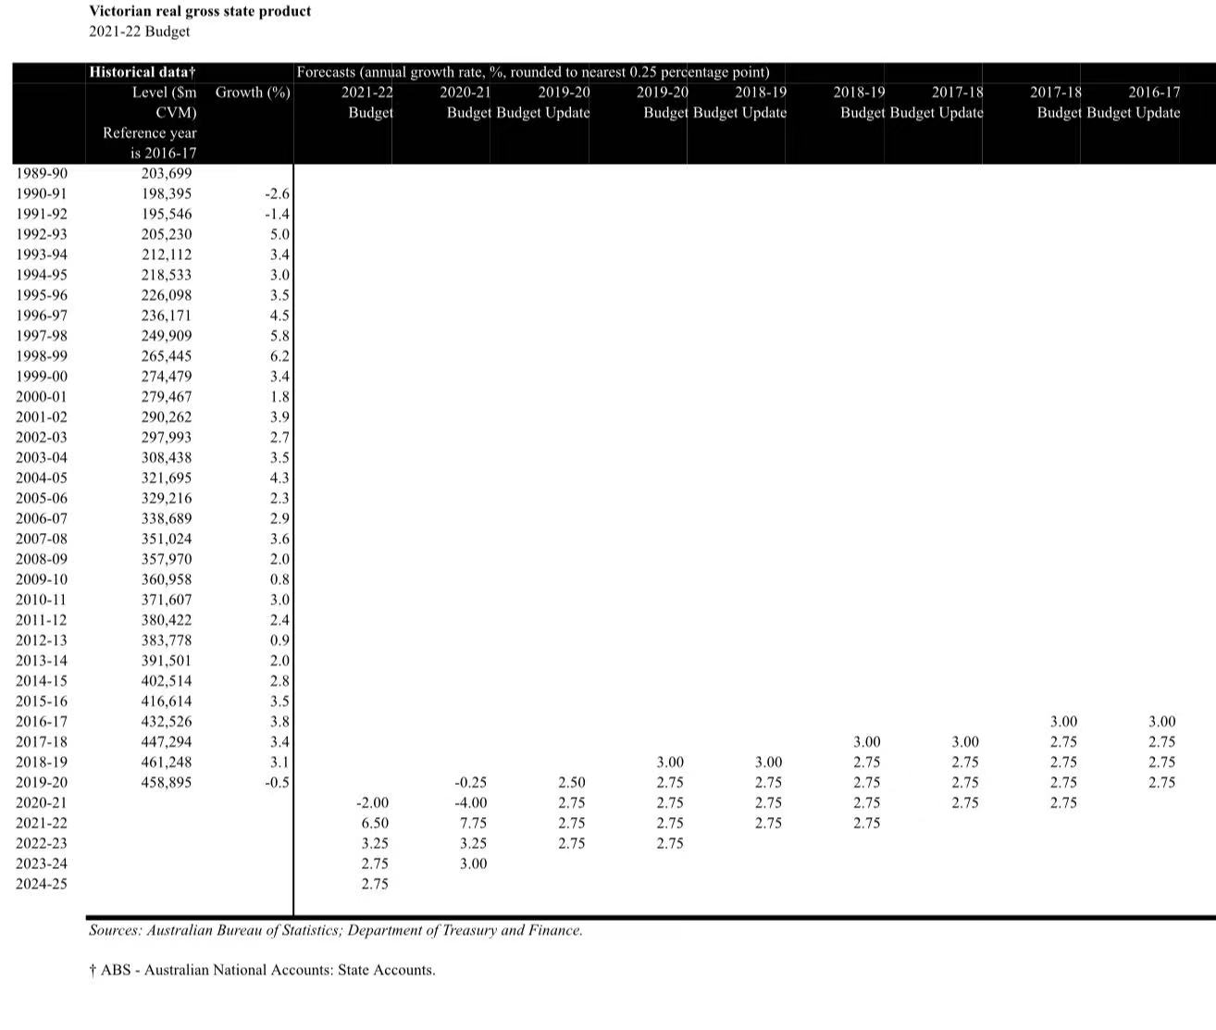

(Figure1)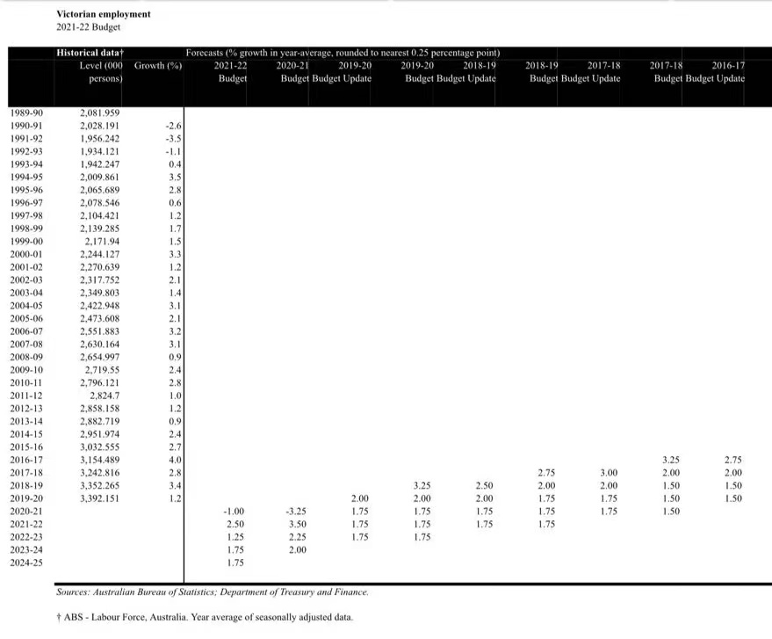

(Figure 2)

Victoria Real Gross State Product include the rate of RGSP’s growth of Victoria each year, and Victoria’s employment include the rate of employment’s growth of Victoria each year from 1989-2020. The reason for choosing this dataset is that it can help to figure out whether the Victoria employment rate has the relation with Victoria RGSP growth through analyze the relationship between the rate of employment growth and the rate of Real Gross State Product growth of Victoria. In this report, it will only use the rate of RGSP growth of Victoria of each year and the rate of employment growth of Victoria each year between 2010-2020 to make sure the timeliness and accuracy. Firstly, 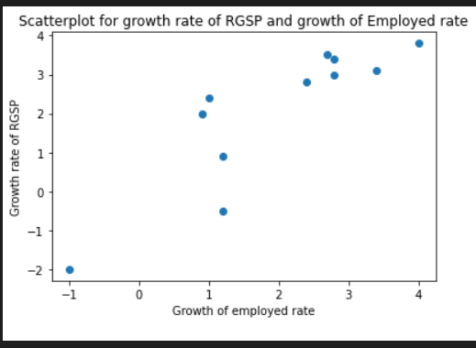using scatterplot (Figure 3)

(Figure 3)

to visualize the dataset - Growth rate of employment and Growth rate of RGSP and draw a best fit line which color is red on the graph and just kind of look at the correlation. It’s show that this scatterplot is a linear - with the growth rate of employment increase, the growth rate of RGSP increase at the same time. But the scatterplot can only hint the correlation between the growth rate of RSGP and the growth rate of employment of Victoria. Secondly, using Pearson Correlation to find the intensity of correlation between two features. The advantage of using Pearson Correlation rather than Euclidean distance is that Pearson Correlation can provide the intensity of correlation between two features more accurately, directly and will not be influence by scale, but Euclidean distance do not have a trade-off standard. By applying the Pearson Correlation’s formula, the Pearson Correlation value is approximately equal to 0.907. According to Jacob Cohen, when the Pearson Correlation value lager than 0.5, these two features have a strong positive correlation. Since the Pearson Correlation value between the growth rate of RGSP of Victoria and the growth rate of employment of Victoria is 0.889 which is bigger than 0.5, they have a strong correlation. It means that the growth rate of employment of Victoria grows more quickly, and the growth rate of Victoria’s RGSP will grow more quickly. And are there any factors will influence the employed rate or unemployment rate and thus affect RGSP. This part will also be discussed in this report.

1. **Relationship between retail sales of cafes, restaurants and takeaway food services and unemployment rate in Victoria**

The concern of this part is the relationship between retail sales of cafes, restaurants and takeaway food services and the unemployment rate in Victoria. Retail plays a critical role in economic growth and recovery, and restaurants will stimulate consumer demand and jobs and contribute to economic growth. Since from figure 1, the rate of employment’s growth has been decreased in 2020 in recent 10 years, so for this part, it will concentrate on the data during COVID-19. During this epidemic, to prevent the spread of the epidemic, several regional governments required local catering service units to suspend business, which led to a sharp decline in business income of many catering businesses and forced them to lay off employees to maintain operations. So, we find a relationship between retail sales and unemployment over that period. To ensure efficiency and accuracy, only retail sales and unemployment data will be used for the period from January 2019 to January 2021, when the COVID-19 outbreak began, to the most recent. In addition, to visualize the data clearly, we will use scatter plots.

First, a set of figures showing retail sales of cafes, restaurants, and takeaway food services in Victoria (Figure 4).

(Figure 4)

The second figure shows the unemployment rate in Victoria (Figure 5). The two data spans from January 2019 to January 2021 and the timeline is divided in months.

(Figure 5)

(Figure 6)

Pearson correlation value is approximately -0.763 by calculation. Since the absolute value is greater than 0.5, it means there is a large negative linear correlation between unemployment rate and retail sales, which can indicate that the worse the retail sales, the higher the unemployment rate.

And we calculated that the coefficient of determination r2 is approximately equal to 0.582, which means there is weaker linear relationships between retail sales and employment rate. So, to some extent, we can assume that unemployment is higher when retail sales are lower.

These results show the relationship between the unemployment rate and retail sales, so that the government can find that it is not feasible to keep bringing the catering industry to a standstill. Besides, the government can timely find the problem and formulate corresponding solutions to achieve sustainable development and prevent RGSP decline.

1. **Relationship between the rental market economy in Victoria and unemployment rate.**

Part of our question is about whether the rental market economy in Victoria has had an impact on the unemployment rate. The housing rental market plays an important role in Victoria's GDP. If the housing rental market is doing well, then the city is on the right track for sustainable development.

There is a dataset called Rental Report - Quarterly: Moving Annual Rents by Suburb (Figure 7). The format of dataset is Excel. It provides a summary of the affordability of rental housing for lower income households in Victoria. The affordability benchmark used is that no more than 30 per cent of gross income is spent on rent. The data in the Rental Report is very detailed, so I will calculate the annual average of the total for the convenience of analysis and plotting. The other dataset is called State budget 2021-22 Macroeconomic Indicators (Figure 8). The format of dataset is also Excel. It provides Victorian unemployment rate. To ensure timeliness and certainty, only rental and unemployment data from 2010 to 2020 are used.

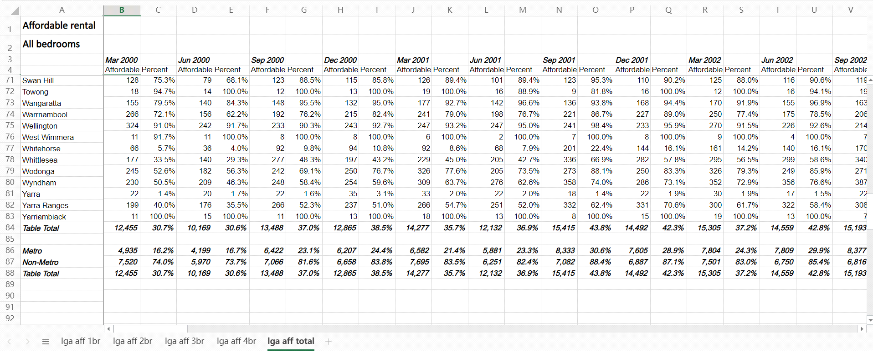

(Figure 7)

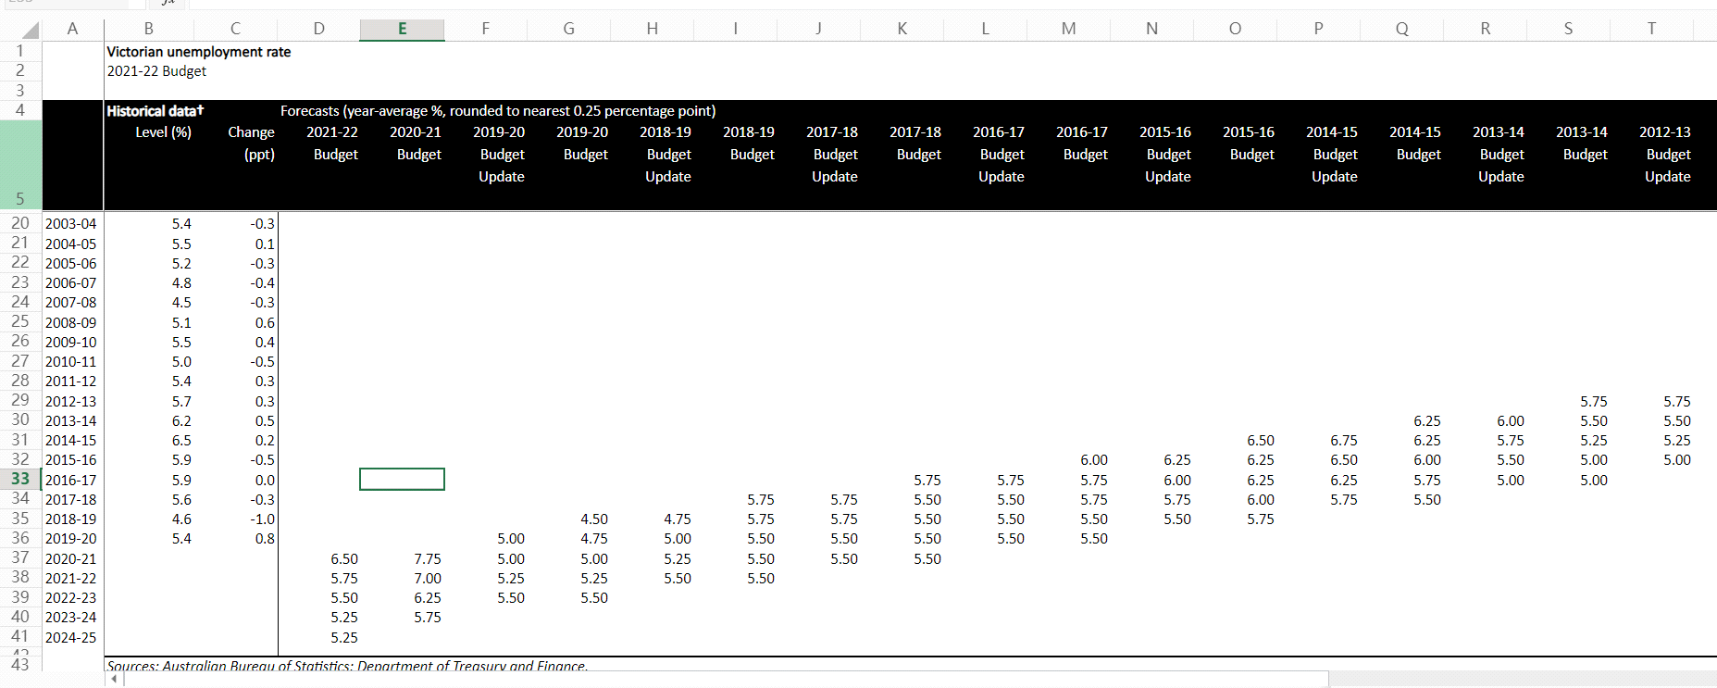

(Figure 8)

The first step is to construct a scatter plot of affordable rental on X-axis and unemployment rate on Y-axis from the two datasets, and then analyze the correlation according to the scatter plot (Figure 9). In the scatter plot, the trend of all points tends to be straight but there are many deviating points. Therefore, Pearson correlation and Mutual information are used to ensure accurate information.

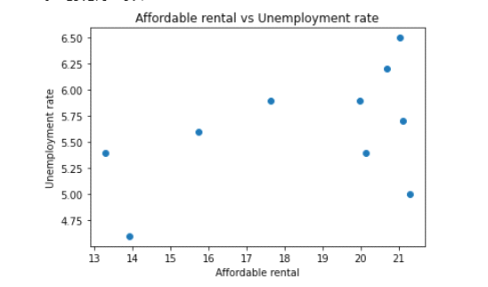

(Figure 9)

For mutual information, the unemployment rates are binned into 3 equal length bins: Low[4.50, 5.25), Medium[5.25, 6.0), Large[6.0, 6.75). The percentage of affordable rentals are also binned into 3 euqal length bins: Low[13, 16), Medium[16, 19), Large[19, 22). Using the code, it is shown that H(X) is approximately 1.295, H(Y) is approximately 1.371, MI(X, Y) is approximately 0.220, and NMI(X, Y) is approximately 0.170. Since the values of MI(X, Y) and NMI(X, Y) are both small, it can be concluded that the correlation between unemployment rate and affordable rental is low. Pearson correlation value is approximately 0.490 by calculation. Since the absolute value of Pearson correlation is between 0.3 and 0.5, it indicates that there is a moderate positive linear correlation between unemployment rate and affordable rental. Therefore, it can be roughly inferred, therefore, that the higher the unemployment rate, the fewer low-income people who can afford rent.

This result is important and valuable because it extrapolates the relationship between unemployment and affordable rent. According to Pearson correlation, low-income people have less people who can afford to rent houses when the unemployment rate increases. This shows that government policies have not helped low-income groups increase GDP and promote sustainable development. Meanwhile, according to mutual Information, the correlation between unemployment rate and affordable rent is low, so the conclusion is not very reliable.

There are many limitations.

1. **Summary**

The report analyses the relationship between employment and Victoria's gross state product. As employment falls, so does the state gross state product. It is possible that losses in sectors such as catering, and accommodation have led to a decline in employment rate thus lower state GDP. Therefore, for the sustainability of Victoria's economy, it is necessary to eliminate the virus, vaccinate and take safety measures as soon as possible, improve the welfare of all industries as much as possible, or increase foreign tourists to restore the economy of all industries, thus effectively reducing unemployment rate and increasing state GDP. If there are still hundreds of new cases a day, it will not be sustainable for Victoria. The first limitation is that the data of 2020 of figure 1 and figure 2 only has a forecast, and this part will be filled and confirmed in the future and be more precise. Secondly, data sample is small, could be a biased sample. Affordable rental only includes low-income people, which is very incomplete. There also may be a 3rd factor influencing or controlling both. This can be improved with a larger and more comprehensive dataset of multiple different factors.

1. **Potential datasets**

* State budget 2021-22 Macroeconomic Indicators

[State budget 2021-22 Macroeconomic Indicators - Datasets - Victorian Government Data Directory](https://discover.data.vic.gov.au/dataset/state-budget-2021-22-macroeconomic-indicators)

* Australia Retail Sales: Victoria: Cafes, Restaurants and Takeaway Food Services: Cafes, Restaurants and Catering Services

<https://www.ceicdata.com/en/australia/retail-sales-anzsic-2006-by-industry-and-state/retail-sales-victoria-cafes-restaurants-and-takeaway-food-services-cafes-restaurants-and-catering-services>

* Australia Unemployment Rate: Victoria

<https://www.ceicdata.com/en/australia/unemployment-rate/unemployment-rate-victoria>

# Rental Report - Quarterly: Moving Annual Rents by Suburb

<https://discover.data.vic.gov.au/dataset/rental-report-quarterly-moving-annual-rents-by-suburb>